www.WomenAndMathMentoring.org

We wish to thank the following persons
and organizations for their continued support of
The Women and Math Mentoring Program

North Carolina Central University Department of Mathematics & Physics
Kenya Lawrence, Durham Public Schools
Alina Castillo, Durham Public Schools
Steve Shafroth

Corporate Sponsors
GlaxoSmithKline
Amgen Foundation
Texas Instruments, Inc.

As a mentor, you can clear the way. Mentors have the unique opportunity to increase diversity, equity, and inclusion. Mentors change lives, but students change mentors’ lives more. A mentor helps individuals discover new facets of themselves.

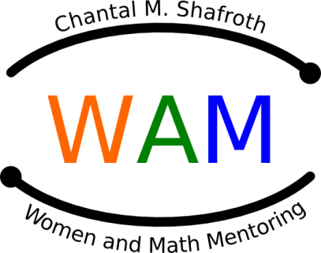

NC Women & Mathematics Network

MENTOR
ORIENTATION
PROGRAM

November 18, 2023

Cary Chamber of Commerce
307 N. Academy Street
Cary, North Carolina 27513

November 18, 2023

Agenda

- 9:00-9:30 Mentor Registration & Breakfast

Session with Mentor Leaders

9:30-10:00 Mentor Orientation

Welcome to WAM!

Secondary Mathematics Update

Major Programs

Field Trips and Projects

- 10:15-10:30 Marjorie Lee Browne Career Day

- 10:30-10:40 Summer Scholarships

M-Cubed

- 10:30-11:15 Mentor Break-Out Sessions
- 11:15-11:30 Question & Answer

