Spring 2013

Women and Math Mentoring Program Newsletter

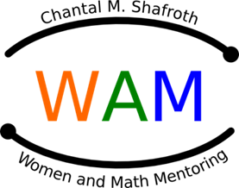

Chantal Marie Marguerite Shafroth was born in Paris, France on April 24, 1930. Chantal received her baccalaureate degree in optical engineering 1949 in Paris. She then applied for and was awarded a prestigious Fulbright travel grant and a President’s Scholarship to study Physics in the US at Johns Hopkins University. She completed her Master’s Degree there and met another Physics Graduate student, Steve Shafroth, whom she later wed. Chantal and Steve moved to Chapel Hill, NC, where Chantal was offered a position at North Carolina Central University in the Mathematics Department. She taught mathematics and computer science for 27 years, until retirement, as an Assistant Professor. She was an innovative and dedicated teacher who was recognized by a “North Carolina Central University Award for Teaching Excellence”. She participated in the design and implementation of acomputer-assisted learning program while at NCCU and won a sabbatical and grant to study and compare the use of computers in high schools in Japan and the US. In 1992, she founded the Women’s Speakers Bureau, in which women in STEM careers spoke to school-aged children. A year later, she joined the Wake County Women and Mathematics Mentoring Program, where she mentored and served on the Planning Committee. After retiring in 1994, she devoted her time to WAM, encouraging girls to pursue studies in mathematics. From this interest, in 1997, Chantal secured funding from the Tensor Foundation to begin a WAM program in Durham County. She was named the cofounder of the Durham Mathematics Mentoring Program.

On April 7, 2012, Chantal died. She is survived by her husband, 3 children, and 5 grandchildren. She will be rememberedfor her energy, vivacity, and her dedication to helping others succeed.

Website: www.womenandmathmentoring.org

Tina Ewing, Director, tewing002@nc.rr.com

Dr. Laura Smith, Newsletter Editor, lbsmith1965@nc.rr.com



# Leader Spotlight – Chantal Shafroth

As the Math Mentoring Program heads into another year, we want you to know that we are thinking about YOU!!! We hope high school is going well, and that you are especially enjoying your math and science classes.

The coordinating team continues to work to improve the program within Durham County.

The opportunities to attend programs during the summer provide for great enrichment and unique experiences that often cannot be accomplished with a traditional school program. This newsletter will provide additional opportunities for summer programs.

It is our hope that you will consider attending one of these programs. If you are in need of a referral or evaluation outside of a teacher recommendation, please feel free to contact your mentor from last year or a member of the coordinating team for assistance.

Contents

Greetings from WAM 1

Leader Spotlight 1

Math Contest 2

Math Websites 2

Math Games 3

Summer Programs 4

## Opportunities inside:

* Math Contest
* Check out some Summer Programs

# Greetings from WAM

## Math Contest ◊ Win a Prize ◊ Math Contest

Try the following problems. The first person to email the correct answers to all three problems will win a prize. By June 6th email solutions to [lbsmith1965@nc.rr.com](mailto:lbsmith1965@nc.rr.com). Please include your name and mailing address for your prize to be sent to you.

A) What is the next number in this series?  
 5   25   61   113   181   ...

B) A Roman girl was given this puzzle:

Take one hundred one, and to it affix the half of a dozen; Put fifty to this, and then you will see what every good boy to others should be.

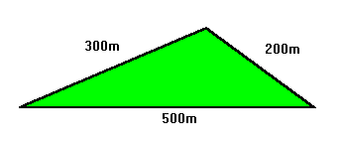

Why didn't the farmer buy the land?

C) A farmer found an advertisement for a plot of land with very good soil and an asking price of $12,500.00. The plot of land looked like the triangle above.

## Math Websites ◊ Check It Out ◊ Math Websites

**www.shodor.org/interactivate**

Interactively explore many different math concepts from fractals to tessellations to probability using Project Interactivate. Interactivate is mathematics courseware freely available for use on the Shodor Education Foundations website. The project contains more than eighty classroom-tested interactive activities and tools for explorations in mathematics.

**www.mathforum.org/students**

This website has weekly and monthly challenging math problems for all ages. In addition, play math games and get help with your homework.

**www.joyofpi.com**

Do you want to know more about ∏? This website includes the first ten thousand digits on Pi, a history of Pi, and other interesting facts. It also includes links to other great websites about Pi.

[**www.pass.maths.org.uk**](http://www.pass.maths.org.uk)

*Plus* magazine is an internet magazine that features news articles and stories about the applications of mathematics in the real world. Be sure to check out the career interviews done with mathematicians.

**www.bls.gov/k12/math.htm**

If you are good at math…check out these careers. This site has ideas about jobs atmosphere, pay potential, job outlooks, and how to get ready for the career.

**www.sandlotscience.com**

This site has examples, explanations and projects based on optical illusions.

**www.thinks.com**

Do you like puzzles? Sudoku, crosswords, jigsaw puzzles and more brain teasers with daily updates.

**www.girlsgotech.org/**

Take a look around, and you'll start to notice that math, science and technology are everywhere!

**www.expandingyourhorizons.org/**

Learn more about women in science, chat with them or have some fun by playing some games.

**http://www.cfnc.org**

Planning, applying and paying for college. Learn which careers match your interests and personality and track your progress towards meeting college entrance requirements.

"Pure mathematics is, in its way, the poetry of logical ideas."

-- Albert Einstein.

Page 2 of 4

Spring 2013

WAM Newsletter

**Solutions???**

**Go to womenandmathmentoring.org**.

**Solutions???**

**Go to womenandmathmentoring.org.**

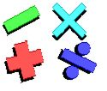

**Problem 1**

**Jim, Kim, Larry, Mina, and Nancy had their pizza dinner at a restaurant.  Each of them had three of the following five toppings:  sausage, pepperoni, mushroom, olives, and green pepper.  The only topping that Jim and Larry had in common was sausage.  The only topping Mina and Nancy had in common was pepperoni.  The only topping Larry and Kim had in common are mushrooms.  The only topping Mina and Kim had in common was green pepper.**

**Identify the toppings each of them had on their pizza.**

Problem 2

**People from the town of Liarsville always tell lies.  Of the following people below, only one is not from Liarsville.  Can you tell which one is the outsider based on the following statements made?**

**Mr. Applebee:  I am very honest.**

**Mrs. Beatle:  Dr. Doodle is not from Liarsville.**

**Ms. Casey:  I am a liar.**

**Dr. Doodle:  Mrs. Beatle does not lie.**

**Mr. Eastwood:  I am from the East.**

**This puzzle dates back to the time of the ancient Greeks.  Ten circular tokens are arranged in the form of a triangle as follows:** 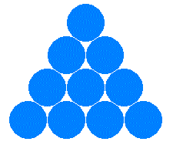

**Move three tokens to so that the triangle becomes upside-down.**

## Logicville

When asked about his age, Grandpa gives this answer:   
  
I am 100 years old, but had only 25 birthdays.

How is that possible? 

What is the least number of triangles you have to remove so that none of the remaining triangles overlap?   
  
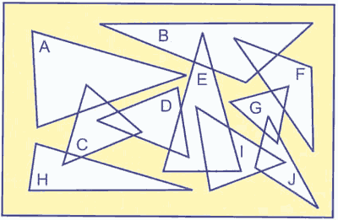

## Math Games ◊ Try To Solve ◊ Math Games

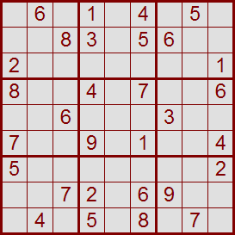There's no math involved.  
The grid has numbers, but nothing has to add up to anything else.  
You solve the puzzle with reasoning   
and logic.

It's fun. It's challenging. It's addictive!

**Spring 2013**

**Page 3 of 4**

WAM Newsletter

**Spring 2013**

WAM Newsletter

**Page 4 of 4**

## Summer Camps ◊ Check It Out and Go

**Programs at NC Central University**

www.nccu.edu/Academics/summer/youth.cfm Phone: (919) 530-6677

**Programs at Shodor Foundation**

**http://www.shodor.org/succeed/workshops/current/**

**The Shodor Scholars Program in Computational Science (SSP)** is a science, mathematics, and computing scholarship program. Students use advanced [computational science](http://www.shodor.org/succeed/ssp/csssp.html) technologies, techniques, and tools to study a wide variety of scientific events.

* **Shodor Scholars Program**

June 29- Aug 9 9am - 4pm

Other workshops at Shodor:

* **Programming Concepts**

June 17-21 9am-noon

* **Web Design**

June 17-21 1pm-4pm

* **Explorations in Engineering at Sigma Xi**

July 15-19 9am-4pm

* **Intro to iPhone Development**

July 24-28 9am-noon

* **Parallel Universe**

July 24-28 1pm-4pm

**Duke University**

www.learnmore.duke.edu/Youth/

Duke Youth Programs is a part of Duke University Continuing Studies and has provided summer academic enrichment for academically motivated youth for over 20 years.

* **Computer Camp**

http://www.learnmore.duke.edu/youth/computer/

Learn computer concepts, techniques, and programming skills that can be applied in more advanced programming and create video games, storyboards, interactive projects.

Jun 24-28; Jul 8-12; or Jul 15-19

**UNC Chapel Hill**

www.internaldrive.com/index.php

A variety of fun cutting edge summer camp courses for kids and teens including video game design, flash animation, programming, video editing and more–using the best brand name products from Adobe®, Apple®, Autodesk®, Microsoft® and beyond. Come explore the UNC Chapel Hill campus and gain technical skills that will last long after summer camp ends. Ignite your internalDrive and do something big this summer!

Various camps are available.



**Programs at NC State University**

http://www.ncsu.edu/precollege/highschool.html

* **the engineering place**

**http://www.engr.ncsu.edu/theengineeringplace/summerprograms/index.php**

Discover what engineering is all about. In 2013 we will have programs in Raleigh and Rocky Mount.

Jul 8-12

* **VETCamp**

**http://harvest.cals.ncsu.edu/vetpac/index.cfm?pageID=5165**

**The camp is designed for students who are interested in becoming veterinary healthcare professionals and provides a preview into the real and vast fields of veterinary medicine. Jul 8-12; Jul 15–19**

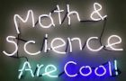

Check out this link for more camp opportunities:

**MySummerCamps.com**

