Spring 2012

**ANSWER**

**Ms. Casey, who said that "I am a liar", is not from Liarsville.  People from Liarsville always tell lies.  The statement "I am a liar" could not be made by someone who always tell lies.  It can also be noted that the rest of the people lied.**

ANSWER

Jim: Sausage, Green Peppers, Olives

Larry: Sausage, Mushrooms, Pepperoni

Kim: Mushroom, Green Peppesr, Olives

Minna: Sausage, Green Peppers, Pepperoni

Nancy: Mushroom, Pepperoni, Olives

Page 2 of 4

WAM Newsletter

**Problem 1**

**Jim, Kim, Larry, Mina, and Nancy had their pizza dinner at a restaurant.  Each of them had three of the following five toppings:  sausage, pepperoni, mushroom, olives, and green pepper.  The only topping that Jim and Larry had in common was sausage.  The only topping Mina and Nancy had in common was pepperoni.  The only topping Larry and Kim had in common are mushrooms.  The only topping Mina and Kim had in common was green pepper.**

**Identify the toppings each of them had on their pizza.**

Problem 2

**People from the town of Liarsville always tell lies.  Of the following people below, only one is not from Liarsville.  Can you tell which one is the outsider based on the following statements made?**

**Mr. Applebee:  I am very honest.**

**Mrs. Beatle:  Dr. Doodle is not from Liarsville.**

**Ms. Casey:  I am a liar.**

**Dr. Doodle:  Mrs. Beatle does not lie.**

**Mr. Eastwood:  I am from the East.**

## Logicville

## Math Games ◊ Try To Solve ◊ Math Games

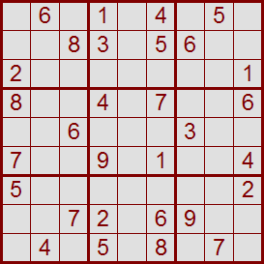There's no math involved.  
The grid has numbers, but  
nothing has to add up to anything else.  
You solve the puzzle with reasoning   
and logic.

It's fun. It's challenging. It's addictive!

**Page 1 of 2**

WAM Newsletter

|  |  |  |  |  |  |  |  |  |  |  |  |  |  |  |  |  |  |  |  |  |  |  |  |  |  |  |  |  |  |
| --- | --- | --- | --- | --- | --- | --- | --- | --- | --- | --- | --- | --- | --- | --- | --- | --- | --- | --- | --- | --- | --- | --- | --- | --- | --- | --- | --- | --- | --- |
| |  |  |  | | --- | --- | --- | | **9** | **6** | **3** | | **1** | **7** | **8** | | **2** | **5** | **4** | | |  |  |  | | --- | --- | --- | | **1** | **7** | **4** | | **3** | **2** | **5** | | **6** | **8** | **9** | | |  |  |  | | --- | --- | --- | | **2** | **5** | **8** | | **6** | **4** | **9** | | **7** | **3** | **1** | |
| |  |  |  | | --- | --- | --- | | **8** | **2** | **1** | | **4** | **9** | **6** | | **7** | **3** | **5** | | |  |  |  | | --- | --- | --- | | **4** | **3** | **7** | | **8** | **5** | **2** | | **9** | **6** | **1** | | |  |  |  | | --- | --- | --- | | **5** | **9** | **6** | | **3** | **1** | **7** | | **8** | **2** | **4** | |
| |  |  |  | | --- | --- | --- | | **5** | **8** | **9** | | **3** | **1** | **7** | | **6** | **4** | **2** | | |  |  |  | | --- | --- | --- | | **7** | **1** | **3** | | **2** | **4** | **6** | | **5** | **9** | **8** | | |  |  |  | | --- | --- | --- | | **4** | **6** | **2** | | **9** | **8** | **5** | | **1** | **7** | **3** | |



**ANSWER**

4

What is the least number of triangles you have to remove so that none of the remaining triangles overlap?   
  
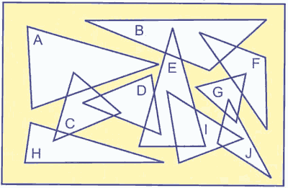

**ANSWER**



**This puzzle dates back to the time of the ancient Greeks.  Ten circular tokens are arranged in the form of a triangle as follows:**



**Move three tokens to so that the triangle becomes upside-down.**

**ANSWER**

This is possible because he was born on February 29th, which only comes around 1 time every 4 years. So, 25 birthdays x 4 (every 4 years)= 100 years old!

When asked about his age, Grandpa gives this answer:   
  
I am 100 years old, but had only 25 birthdays.

How is that possible? 